Week 3: x and ÷ (short method) -
- 136 x 5
- 4.217 x 6
- 82.09 x 7
- 732 ÷ 3
- 211 ÷ 5
- 371.7 ÷ 9

Q7.
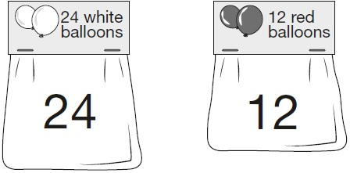
Adam buys 6 bags of white balloons.
Chen buys 3 bags of red balloons.
Adam says,
‘I have four times as many balloons as Chen.’
Explain why Adam is correct.
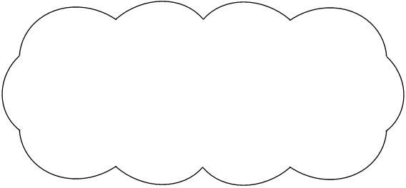
1 mark

Q8.
Alfie says,
‘When you multiply two numbers together, the answer
is always greater than either of the numbers you
started with.'
Is Alfie correct?
Circle Yes or No.
Yes / No
Explain how you know.
1 mark

Q9.
Here is a number pyramid.
The number in a box is the product of the two numbers below it.
Write the missing numbers.

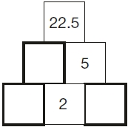
2 marks

Q10.

3 pineapples cost the same as 2 mangoes.  One mango costs £1.35 | 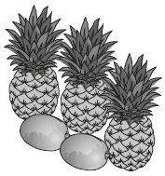
How much does one pineapple cost?
2 marks

