Week 4: long multiplication
- 45 x 22
- 76 x 39
- 108 x 64
- 61 x 1.3
- 7.2 x 2.8

Q6
Write the two missing digits to make this long multiplication correct.

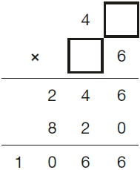
2 marks

Q7.
A box contains trays of melons.

There are 15 melons in a tray.  There are 3 trays in a box. | 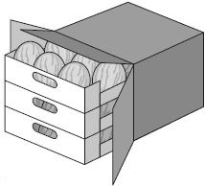
A supermarket sells 40 boxes of melons.
How many melons does the supermarket sell?
2 marks

Q8.
The length of an alligator can be estimated by:
• measuring the distance from its eyes to its nose
• then multiplying that distance by 12
What is the difference in the estimated lengths of these two alligators?
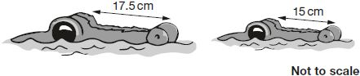
2 marks

Q9.
A toy shop orders 11 boxes of marbles.
Each box contains 6 bags of marbles.
Each bag contains 45 marbles.
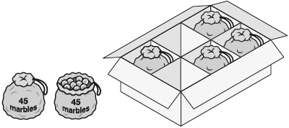
How many marbles does the shop order in total?
2 marks

Q10.
A square tile measures 20 cm by 20 cm.
A rectangular tile is 3 cm longer and 2 cm narrower than the square tile.
What is the difference in area between the two tiles?
3 marks

